Red-Black Tree (courtesy:Geeks for Geeks)

**Introduction:**

A red-black tree is a kind of self-balancing binary search tree where each node has an extra bit, and that bit is often interpreted as the colour (red or black). These colours are used to ensure that the tree remains balanced during insertions and deletions. Although the balance of the tree is not perfect, it is good enough to reduce the searching time and maintain it around O(log n) time, where n is the total number of elements in the tree. This tree was invented in 1972 by Rudolf Bayer.

It must be noted that as each node requires only 1 bit of space to store the colour information, these types of trees show identical memory footprint to the classic (uncoloured) binary search tree.

**Rules That Every Red-Black Tree Follows:**

1. Every node has a colour either red or black.
2. The root of tree is always black.
3. There are no two adjacent red nodes (A red node cannot have a red parent or red child).
4. Every path from a node (including root) to any of its descendant NULL node has the same number of black nodes.

**Why Red-Black Trees?**

Most of the BST operations (e.g., search, max, min, insert, delete.. etc) take O(h) time where h is the height of the BST. The cost of these operations may become O(n) for a skewed Binary tree. If we make sure that the height of the tree remains O(log n) after every insertion and deletion, then we can guarantee an upper bound of O(log n) for all these operations. The height of a Red-Black tree is always O(log n) where n is the number of nodes in the tree.

| Sr. No. | Algorithm | Time Complexity |
| --- | --- | --- |
| 1. | Search | O(log n) |
| 2. | Insert | O(log n) |
| 3. | Delete | O(log n) |

**“n” is the total number of elements in the red-black tree.**

**Comparison with**[**AVL Tree**](https://www.geeksforgeeks.org/avl-tree-set-1-insertion/)**:**

The AVL trees are more balanced compared to Red-Black Trees, but they may cause more rotations during insertion and deletion. So if your application involves frequent insertions and deletions, then Red-Black trees should be preferred. And if the insertions and deletions are less frequent and search is a more frequent operation, then AVL tree should be preferred over Red-Black Tree.

**How does a Red-Black Tree ensure balance?**

A simple example to understand balancing is, a chain of 3 nodes is not possible in the Red-Black tree. We can try any combination of colours and see all of them violate Red-Black tree property.

A chain of 3 nodes is nodes is not possible in Red-Black Trees.

Following are **NOT** Red-Black Trees

**30** **30** **30**

/ \ / \ / \

**20** NIL **20 N**IL **20** NIL

/ \ / \ / \

**10** NIL **10** NIL **10** NIL

Violates Violates Violates

Property 4. Property 4 Property 3

Following are different possible Red-Black Trees with above 3 keys

**20**  **20**

/ \ / \

**10 30** **10 30**

/ \ / \ / \ / \

NIL NIL NIL NIL NIL NIL NIL NIL

**Interesting points about Red-Black Tree:**

1. Black height of the red-black tree is the number of black nodes on a path from the root node to a leaf node. Leaf nodes are also counted as black nodes. So, a red-black tree of height h has black height >= h/2.
2. Height of a red-black tree with n nodes is h<= 2 log2(n + 1).
3. All leaves (NIL) are black.
4. The black depth of a node is defined as the number of black nodes from the root to that node i.e the number of black ancestors.
5. Every red-black tree is a special case of a binary tree.

**Black Height of a Red-Black Tree :**

Black height is the number of black nodes on a path from the root to a leaf. Leaf nodes are also counted black nodes. From the above properties 3 and 4, we can derive, **a Red-Black Tree of height h has black-height >= h/2**.

*Number of nodes from a node to its farthest descendant leaf is no more than twice as the number of nodes to the nearest descendant leaf.*

**Every Red Black Tree with n nodes has height <=**2Log2(n+1)   
This can be proved using the following facts:

1. For a general Binary Tree, let **k** be the minimum number of nodes on all root to NULL paths, then n >= 2k – 1 (Ex. If k is 3, then n is at least 7). This expression can also be written as k <= Log2(n+1).
2. From property 4 of Red-Black trees and above claim, we can say in a Red-Black Tree with n nodes, there is a root to leaf path with at-most Log2(n+1) black nodes.
3. From property 3 of Red-Black trees, we can claim that the number of black nodes in a Red-Black tree is at least ⌊ n/2 ⌋ where n is the total number of nodes.

From the above points, we can conclude the fact that Red Black Tree with **n** nodes has height <= 2Log2(n+1)

**Example: Searching 11 in the following red-black tree.** 

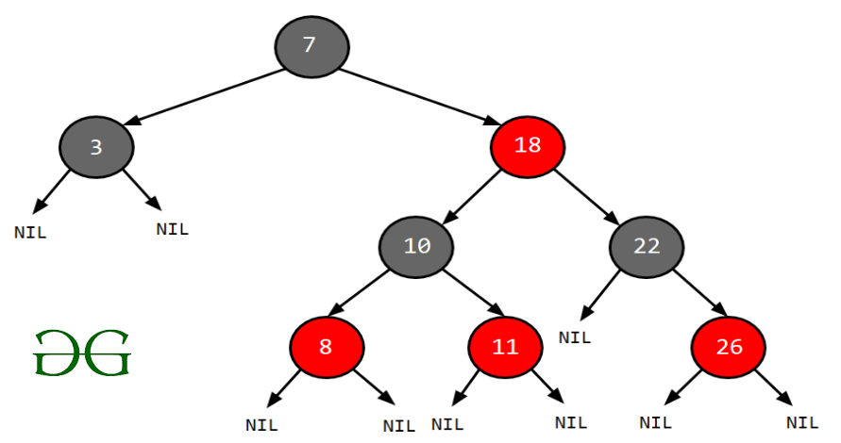

**Solution:**

1. Start from the root.
2. Compare the inserting element with root, if less than root, then recurse for left, else recurse for right.
3. If the element to search is found anywhere, return true, else return false.

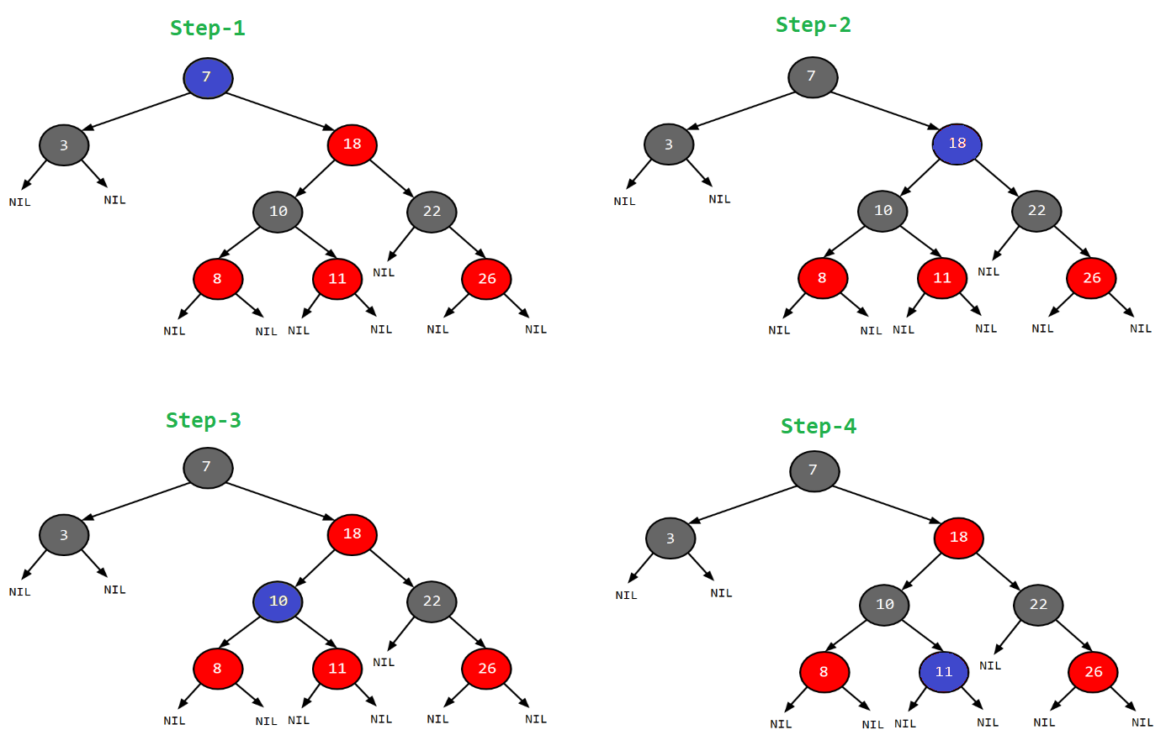Just follow the blue bubble.

.

**Applications:**

1. Most of the self-balancing BST library functions like map and set in C++ (OR TreeSet and TreeMap in Java) use Red-Black Tree.
2. It is used to implement CPU Scheduling Linux. [Completely Fair Scheduler](https://en.wikipedia.org/wiki/Completely_Fair_Scheduler) uses it.
3. Besides they are used in the K-mean clustering algorithm for reducing time complexity.
4. Moreover, MySQL also uses the Red-Black tree for indexes on tables.

Red-Black Tree (Insert)

The algorithms have mainly two cases depending upon the colour of the uncle. If the uncle is red, we do recolour. If the uncle is black, we do rotations and/or recolouring.

**The representation we will be working with is:**

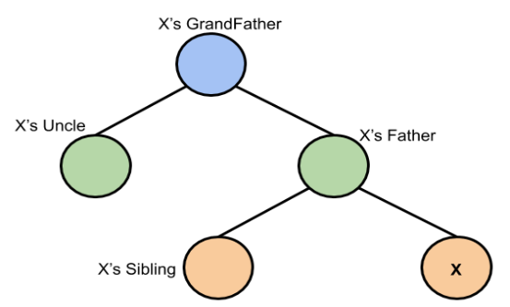

*This representation is based on X*

**Logic:**

First, you have to insert the node similarly to that in a binary tree and assign a red colour to it. Now, if the node is a root node then change its colour to black, but if it does not then check the colour of the parent node. If its colour is black then don’t change the colour but if it is not i.e. it is red then check the colour of the node’s uncle. If the node’s uncle has a red colour then change the colour of the node’s parent and uncle to black and that of grandfather to red colour and repeat the same process for him (i.e. grandfather).

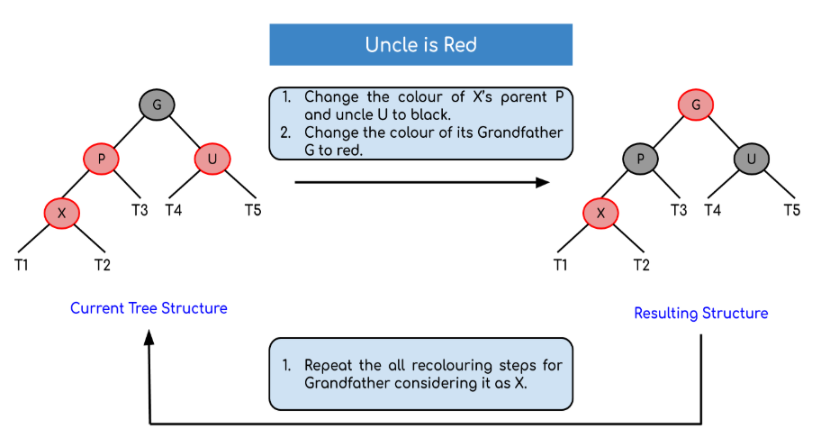

But, if the node’s uncle has black colour then there are 4 possible cases:

* Left Left Case (LL rotation):

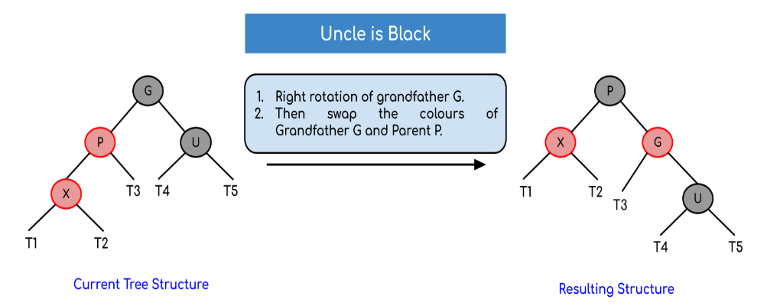

* Left Right Case (LR rotation):

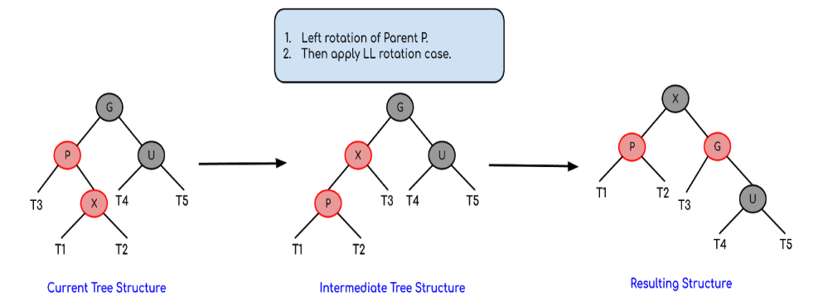

* Right Right Case (RR rotation):

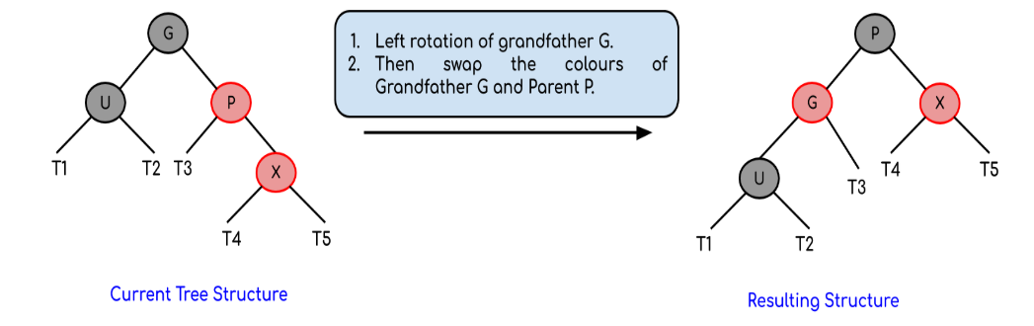

* Right Left Case (RL rotation):

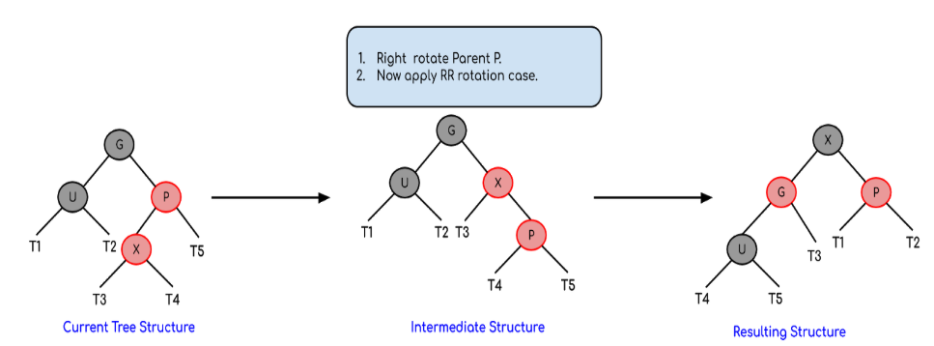

Now, after these rotations, if the colours of the nodes are miss matching then recolour them.

**Algorithm:**

Let x be the newly inserted node.

1. Perform [standard BST insertion](http://geeksquiz.com/binary-search-tree-set-1-search-and-insertion/) and make the colour of newly inserted nodes as RED.
2. If x is the root, change the colour of x as BLACK (Black height of complete tree increases by 1).
3. Do the following if the color of x’s parent is not BLACK **and** x is not the root.   
   **a) If x’s uncle is** **RED** (Grandparent must have been black from [property 4](https://www.geeksforgeeks.org/red-black-tree-set-1-introduction-2/))   
   **(i)** Change the colour of parent and uncle as BLACK.   
   **(ii)** Colour of a grandparent as RED.   
   **(iii)** Change x = x’s grandparent, repeat steps 2 and 3 for new x.

**b) If x’s uncle is BLACK**, then there can be four configurations for x, x’s parent (**p**) and x’s grandparent (**g**) (This is similar to[AVL Tree](https://www.geeksforgeeks.org/avl-tree-set-1-insertion/))   
**(i)** Left Left Case (p is left child of g and x is left child of p)   
**(ii)** Left Right Case (p is left child of g and x is the right child of p)   
**(iii)** Right Right Case (Mirror of case i)   
**(iv)** Right Left Case (Mirror of case ii)

**Example: Creating a red-black tree with elements 3, 21, 32 and 17 in an empty tree.**

**Solution:**



*When the first element is inserted it is inserted as a root node and as root node has black colour so it acquires the colour black.*



*The new element is always inserted with a red colour and as 21 > 3 so it becomes the part of the left subtree of the root node.*

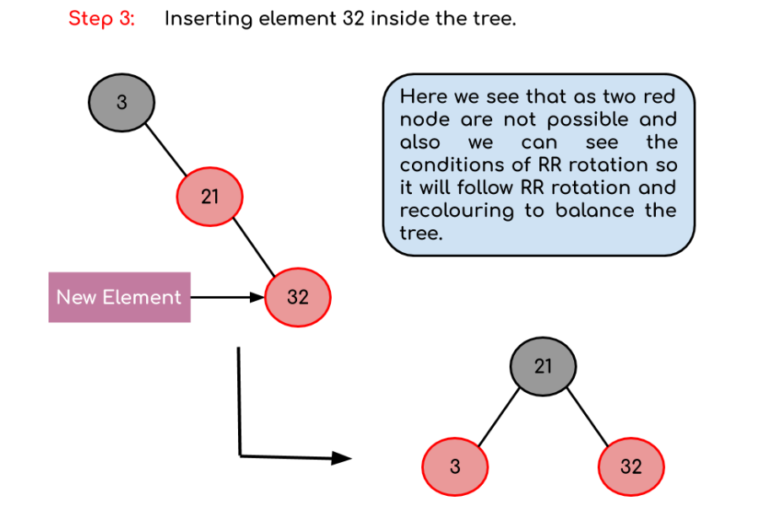

*Now, as we insert 32 we see there is a red father-child pair which violates the Red-Black tree rule so we have to rotate it. Moreover, we see the conditions of RR rotation (considering the null node of the root node as black) so after rotation as the root node can’t be Red so we have to perform recolouring in the tree resulting in the tree shown above.*

 Red-Black Tree (Delete)

**Insertion Vs Deletion:**   
Like Insertion, recoloring and rotations are used to maintain the Red-Black properties.  
In the insert operation, we check the color of the uncle to decide the appropriate case. In the delete operation, ***we check the color of the sibling*** to decide the appropriate case.  
The main property that violates after insertion is two consecutive reds. In delete, the main violated property is, change of black height in subtrees as deletion of a black node may cause reduced black height in one root to leaf path.  
Deletion is a fairly complex process.  To understand deletion, the notion of double black is used.  When a black node is deleted and replaced by a black child, the child is marked as ***double black***. The main task now becomes to convert this double black to single black.  
**Deletion Steps**   
Following are detailed steps for deletion.  
**1)** Perform [standard BST delete](http://geeksquiz.com/binary-search-tree-set-2-delete/). When we perform standard delete operation in BST, we always end up deleting a node which is an either leaf or has only one child (For an internal node, we copy the successor and then recursively call delete for successor, successor is always a leaf node or a node with one child). So we only need to handle cases where a node is leaf or has one child. Let v be the node to be deleted and u be the child that replaces v (Note that u is NULL when v is a leaf and color of NULL is considered as Black).  
**2) Simple Case: If either u or v is red,** we mark the replaced child as black (No change in black height). Note that both u and v cannot be red as v is parent of u and two consecutive reds are not allowed in red-black tree. 

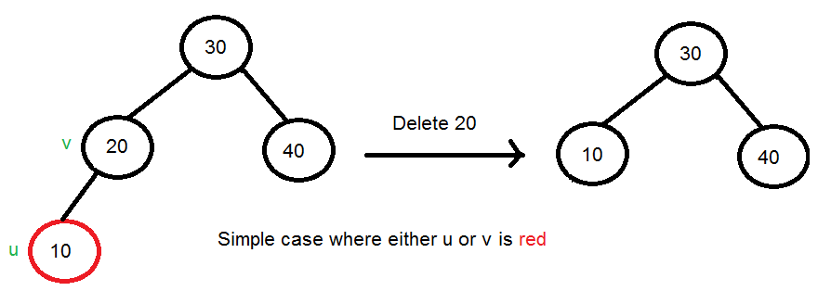

**3) If Both u and v are Black**.  
**3.1)** Color u as double black.  Now our task reduces to convert this double black to single black. Note that If v is leaf, then u is NULL and color of NULL is considered black. So the deletion of a black leaf also causes a double black.

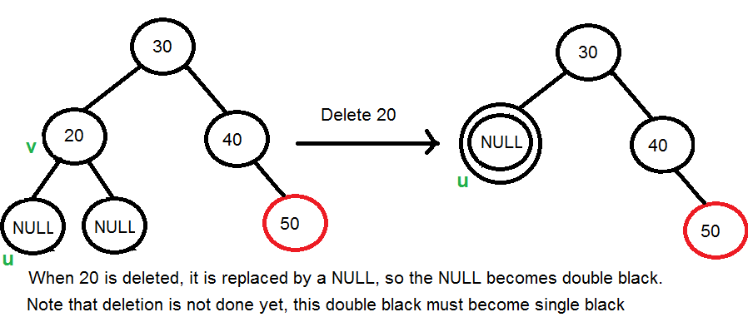

**3.2)** Do following while the current node u is double black, and it is not the root. Let sibling of node be **s**.   
….**(a): If sibling s is black and at least one of sibling’s children is red**, perform rotation(s). Let the red child of s be **r**. This case can be divided in four subcases depending upon positions of s and r.  
…………..**(i)** Left Left Case (s is left child of its parent and r is left child of s or both children of s are red). This is mirror of right right case shown in below diagram.  
…………..**(ii)** Left Right Case (s is left child of its parent and r is right child). This is mirror of right left case shown in below diagram.  
…………..**(iii)** Right Right Case (s is right child of its parent and r is right child of s or both children of s are red) 

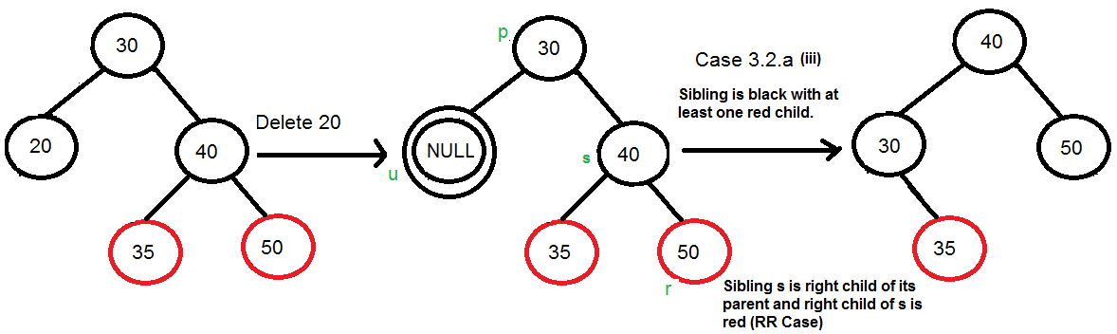

…………..**(iv)** Right Left Case (s is right child of its parent and r is left child of s) 

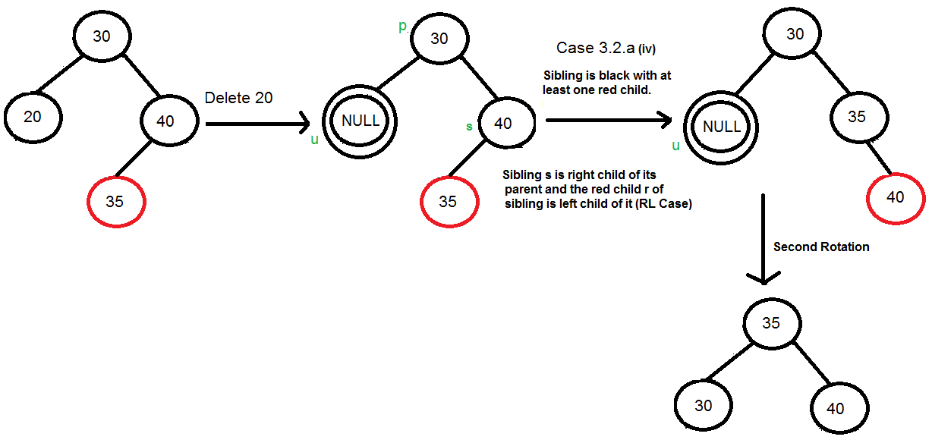

…..**(b): If sibling is black and its both children are black**, perform recoloring, and recur for the parent if parent is black. 

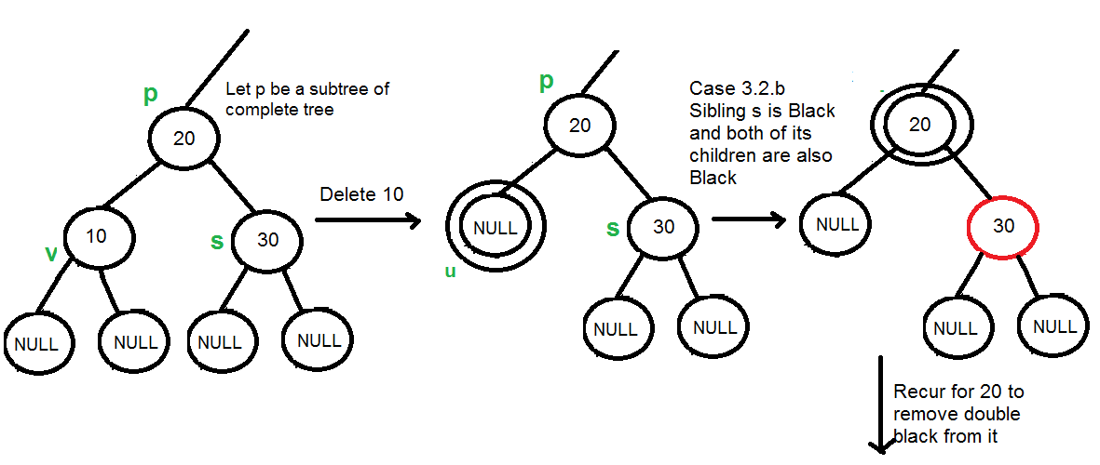

In this case, if parent was red, then we didn’t need to recur for parent, we can simply make it black (red + double black = single black)  
…..**(c): If sibling is red**, perform a rotation to move old sibling up, recolor the old sibling and parent. The new sibling is always black (See the below diagram). This mainly converts the tree to black sibling case (by rotation) and leads to case (a) or (b). This case can be divided in two subcases.   
…………..**(i)** Left Case (s is left child of its parent). This is mirror of right right case shown in below diagram. We right rotate the parent p.   
…………..**(iii)** Right Case (s is right child of its parent). We left rotate the parent p. 

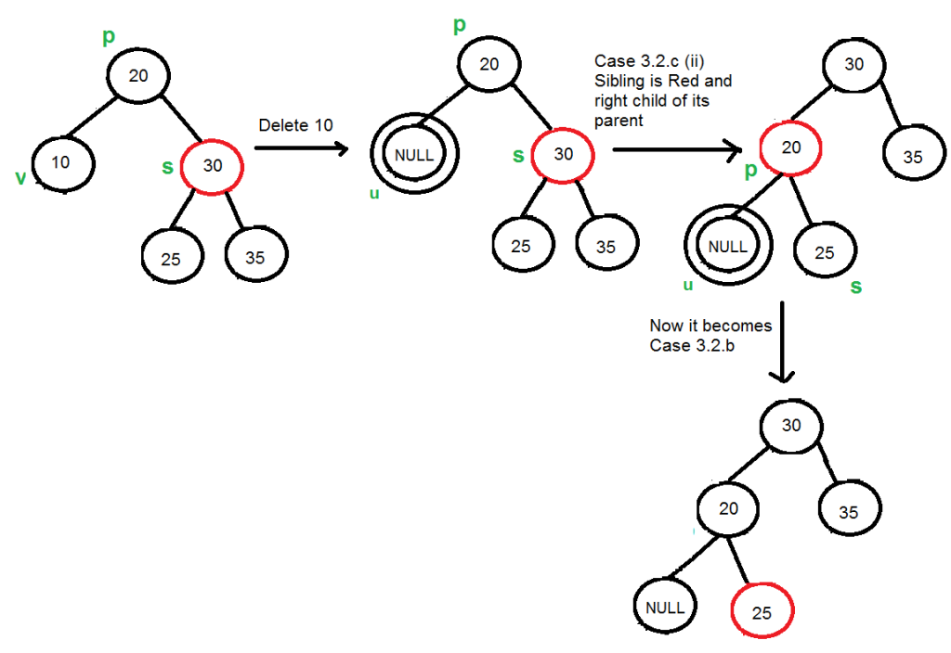

**3.3)** If u is root, make it single black and return (Black height of complete tree reduces by 1).

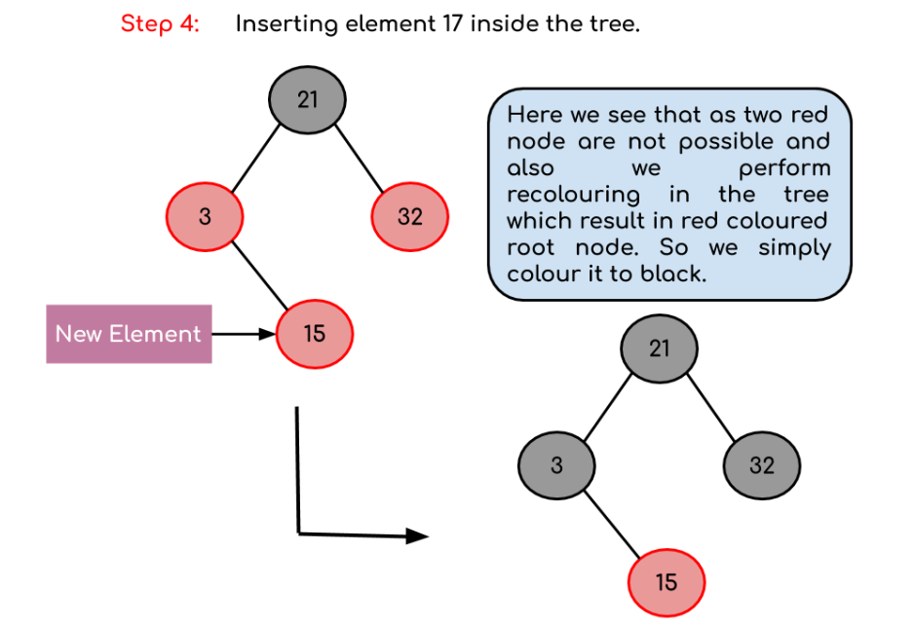

*Now when we insert the new element the parent and the child node with red colour appear again and here we have to recolour them. We see that both the parent node and the uncle node have red colour so we simply change their colour to black and change the grandfather colour to red. Now, as a grandfather is the root node so we again change its colour to black resulting in the tree shown above.*

**Final Tree Structure:**



*The final tree will look like this*